The Future Workforce

GLOBAL NATURAL RESOURCES 2022 SURVEY REPORT

Attracting the Next Generation: Turning Sceptics into Changemakers

March 2022
Companies in the natural resources sector have a key role to play in the global decarbonisation process.
As an industry, it has the most potential to contribute towards a greener future - and yet it faces unprecedented recruitment pressures, with the attractiveness of a career in this area being called into question by new entrants into the workforce.
To find out more, BDO commissioned a survey of school and university students, plus industry leaders (from Australia, Canada, Latin America, South Africa, and the United Kingdom) on their career aspirations and their perceptions of the natural resources industry/the types of careers available.
With more than 750 respondents and both global and regional analysis, the research results highlight Gen Z’s (the generation born between 1997 and 2012) concern around job security - and their desire to save the planet. Evidently, there is a distinct gap between what Gen Z wants and what the industry currently offers, but it is a gap that can and should be closed.
Building the right talent pipeline is crucial for future success in the natural resources industry. Our global report presents:
- a range of talent strategies
- lessons learned from other sectors
- suggestions of how industry leaders can address Gen Z’s wish list of practical improvements
- steps towards organic changes as clients are facing modern challenges

Download the Future Workforce report by BDO Global Natural Resources here.
DOWNLOAD FULL REPORT

INFOGRAPHIC: THE VIEW FROM THE STUDENTS
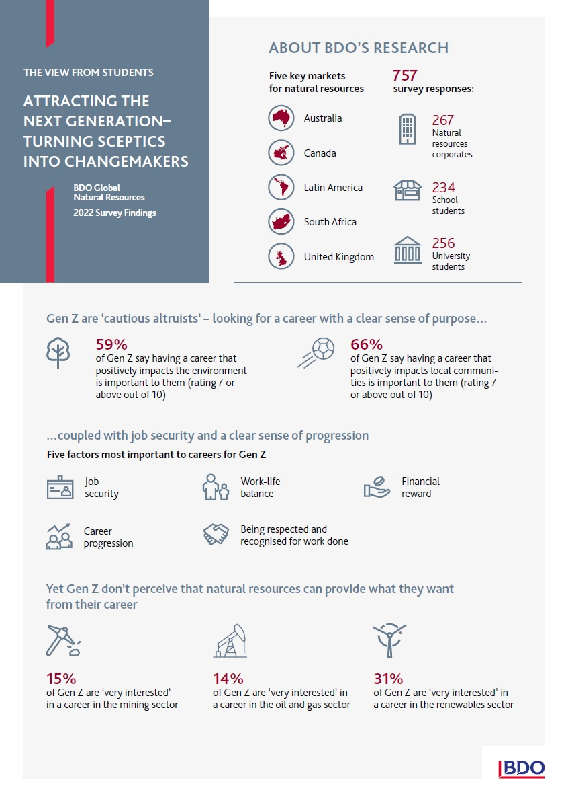

INFOGRAPHIC: THE VIEW FROM THE INDUSTRY
